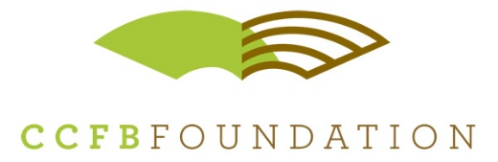

801 North Country Fair Drive, Suite A – Champaign, IL 61821
office – 217.352.5235 mobile – 217.493-4187
www.ccfbfoundation.com
For Immediate Release
December 15, 2015

Agriculture Scholarships Available to Industry’s Future Leaders

As demand for agricultural professionals grow, one in seventeen careers in Illinois are directly related to agriculture; and in Champaign County alone, the industry boasts an employment of nearly 2,800 residents. Looking to support an industry thirsty for agricultural professionals, the Champaign County Farm Bureau Foundation provides scholarships to local students pursuing a post-secondary degree in an agricultural or related field of study.

“As the cost of college continues to skyrocket, today’s college graduates enter the workforce with both a degree and a large amount of student debt. That’s why what we’re doing at the Foundation is so important” says Farm Bureau Foundation Executive Director Kirk Builta.

In addition to enrollment at an accredited college or university in an agricultural or related curriculum, successful applicants must maintain exceptional academic performance as well as community and school involvement. Applicants must be Champaign County residents and/or graduates (or graduating High School Seniors) of a High School located in Champaign County. Ultimately, the most qualified applicants will work to make a positive impact on future of the agricultural industry.

Builta says it’s important for all college-bound students to consider studying agriculture and applying for Farm Bureau Scholarships. “Agriculture is such a large sector and has always been more than corn, and cows. This year our students are studying food sciences, engineering, meteorology and other agricultural-related degree paths.”

Scholarship applications can be found on the Farm Bureau Foundation’s website and are due no later than March 1st, 2016. Visit www.ccfbfoundation.com/apply to download the application.

The Champaign County Farm Bureau Foundation provides educational opportunities that impact the future of the food and agricultural industry in Champaign County, and around the world. Since its inception in 1986, the Foundation is proud to have provided 360 Champaign County students the encouragement and financial resources to succeed in college. In addition, the Foundation’s Ag in the Classroom program - Earth Partners, educates over 9,000 local primary school students annually. The Earth Partners’ programs connects students to the food system and educates of agriculture’s importance in our local communities.
------ ------ ------

For more information contact:
Kirk Builta, Executive Director
Champaign County Farm Bureau Foundation
Office: (217) 352-5235
Mobile: (217) 493-4187
kirk@ccfarmbureau.com

