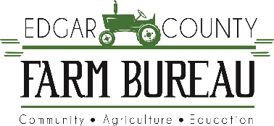
Meet the Candidates
Dear Jim Acklin,
Thank you for agreeing to participate in our Meet the Candidates event on March 2nd at Crestwood Schools in the gym set for 6 PM. We are very excited to introduce you to the members of the Farm Bureau. We hope to have a great discussion on important issues pertinent to our members and the community. In addition, we aim to have a friendly forum without attacks on other candidates or their statements. Below is information on the format of the event.
- Opening Statement (4 minutes)
- Questions
  - Same question presented to each candidate
  - 3 minute response limit
  - Color coded cards will be held up in the back with written text.
    - Yellow = 30 seconds left
    - Red = Time is up. Finish statement
    - Moderator will intervene if needed
- Closing Statements (4 minutes)

- Names will be drawn to provide the order of opening statements. The candidates will then rotate who answers 1st, 2nd and last for each question from then on.
- Candidates will appear on a stage.
- Podium, microphone, chairs and water will be provided on stage.
- Our moderator Lucas Frye, student of the University of Illinois, will introduce you, provide questions, track time, and guide discussion if necessary.
- Please arrive by 5:30 so we can discuss procedure and meet our moderator before the event begins.

Best,
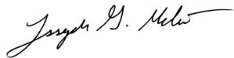
Joe Melisi – Edgar County Farm Bureau Manager

